import pandas as pd

import numpy as np

from sklearn import preprocessing

dataset = pd.read_csv("D:\\ML\\dataset\\train.csv")

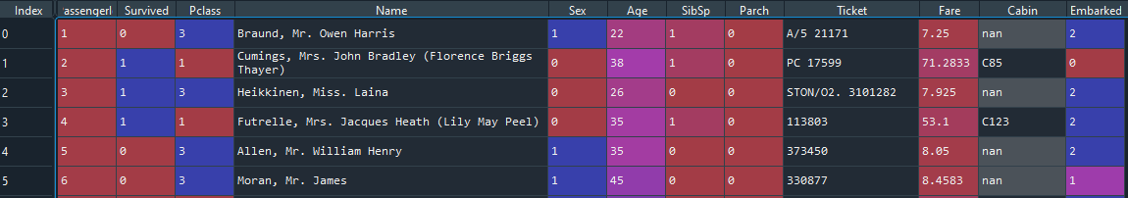

le = preprocessing.LabelEncoder()

dataset['Sex'] = le.fit_transform(dataset['Sex'])

dataset['Embarked'] = le.fit_transform(dataset['Embarked'])

dataset_null = dataset.isnull().sum()

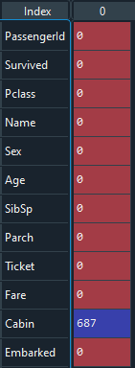

from sklearn.metrics import accuracy_score,confusion_matrix

from sklearn import svm

df = dataset.drop(['PassengerId','Name','Ticket','Cabin'],axis=1)

X = df['Pclass']

y = df.drop(['Pclass'],axis=1)

df['Age'] = df['Age'].astype(int)

df['Fare'] = df['Fare'].astype(int)

from sklearn.model_selection import train_test_split

def svmmodel(X,y):

X_train,X_test,y_train,y_test = train_test_split(X,y,test_size=0.25,random_state=0)

clf = svm.SVC(gamma=0.01,C=100)

clf.fit(X_train,y_train)

y_pred = clf.predict(X_test)

a = accuracy_score(y_test,y_pred,normalize=True)

return a

y1 = df["Pclass"]

X1 = df[['Survived','Sex', 'Age', 'SibSp','Parch','Fare','Embarked']]

svmmodel(X1,y1)

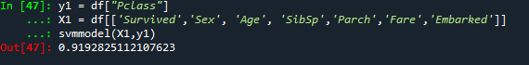

y1 = df['Survived']

X1 = df[['Pclass','Sex', 'Age', 'SibSp','Parch','Fare','Embarked']]

svmmodel(X1,y1)

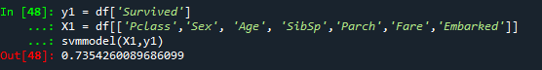

y1 = df['Sex']

X1 = df[['Pclass','Survived', 'Age', 'SibSp','Parch','Fare','Embarked']]

svmmodel(X1,y1)

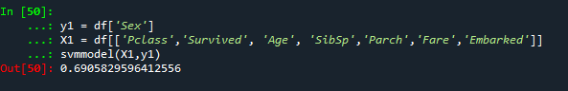

y1 = df['Age']

X1 = df[['Pclass','Survived', 'Sex', 'SibSp','Parch','Fare','Embarked']]

svmmodel(X1,y1)

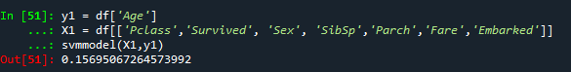

y1 = df['SibSp']

X1 = df[['Pclass','Survived', 'Sex','Age' ,'Parch','Fare','Embarked']]

svmmodel(X1,y1)

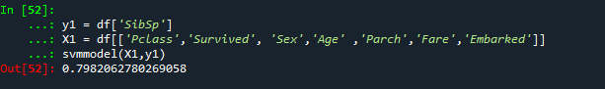

y1 = df['Parch']

X1 = df[['Pclass','Survived', 'Sex','Age' ,'SibSp','Fare','Embarked']]

svmmodel(X1,y1)

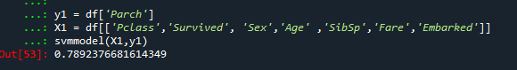

y1 = df['Fare']

X1 = df[['Pclass','Survived', 'Sex','Age' ,'SibSp','Parch','Embarked']]

svmmodel(X1,y1)

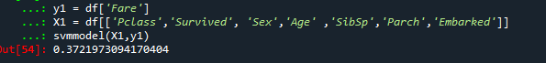

y1 = df['Embarked']

X1 = df[['Pclass','Survived', 'Sex','Age' ,'SibSp','Fare','Parch']]

svmmodel(X1,y1)

